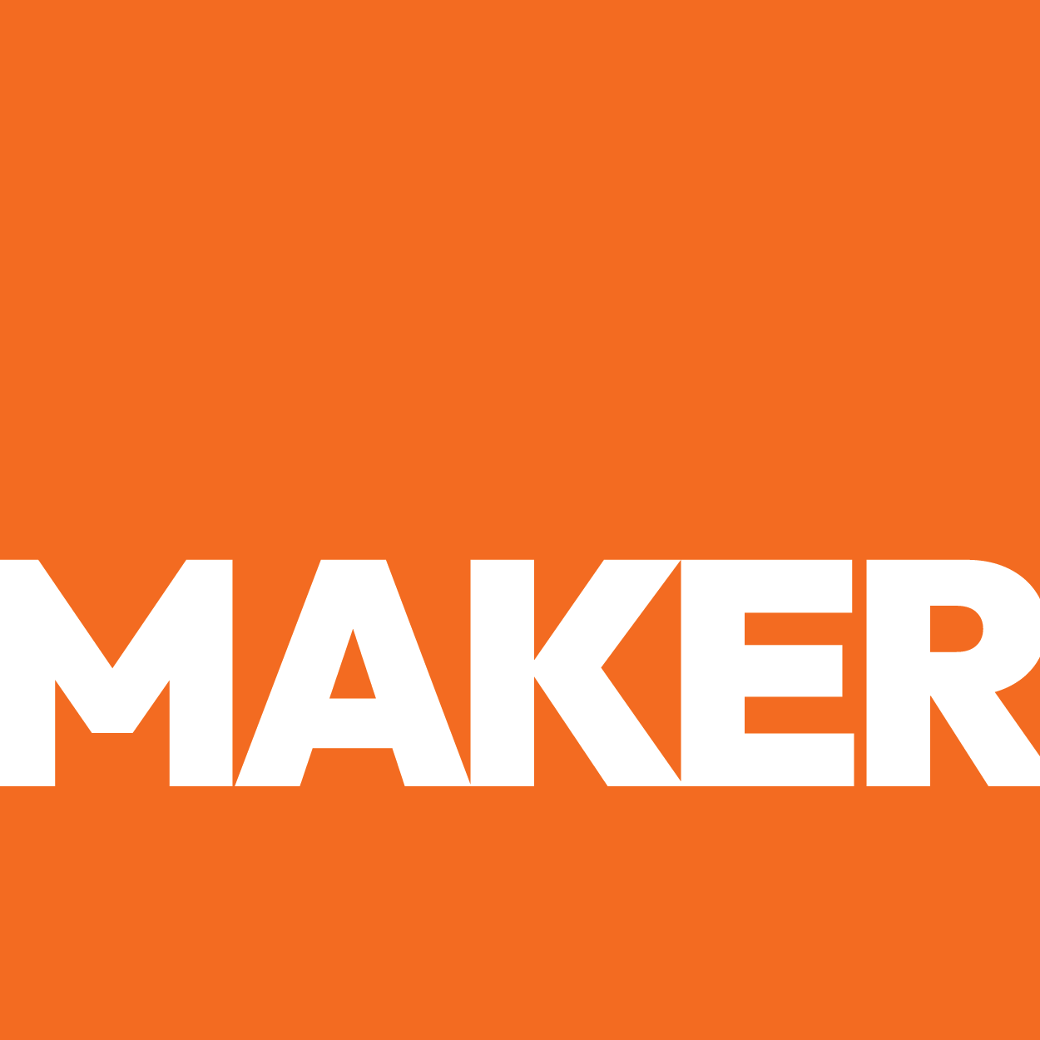

REVENUE GROWTH PLAYBOOK
REVENUE GROWTH
PLAYBOOK

Strategic Offer Architecture for Maximum Revenue Impact
● Prepared by Maker Web Studios ● [Month Year] ●
CONFIDENTIAL — PREPARED EXCLUSIVELY FOR [CLIENT NAME]
OVERVIEW
The Problem — Right Now
[Describe the current offer language — the generic tagline, the audit score, the gap between world-class credentials and a low-scoring website. Be specific.]
What [Client] Actually Is
[Cut through the generic tagline. List the real credentials: years in operation, facility size, certifications, geography. These are the raw materials of the offer.]

"[One sentence positioning statement — what the client actually IS, not what their tagline says.]"
— Maker Web Studios Audit Finding

$[X]K+  BONUS VALUE | [X]+  [Stat 2 Label] | [X]K  [Stat 3 Label] | [Stat 4 Cert]  [Stat 4 Abbrev]
SECTION STEP 1
Pick the Niche
Three Core Services:
- [Service 1]
- [Service 2]
- [Service 3]
Avatar: [Job title, company type, revenue size, geography, situation — be specific.]
Geography: [Primary markets — where the highest-value clients are located or searching from.]

SECTION STEP 2
The Dream Outcome
The [Avatar] does not want a [service]. They want:
- [Dream outcome #1 — specific result, not a feature]
- [Dream outcome #2]
- [Dream outcome #3]
- [Dream outcome #4]
- [Dream outcome #5]

SECTION STEP 3
Four Market Indicators
INDICATOR | [CLIENT] CHECK
Massive Pain | [Market Indicator Massive Pain]
Purchasing Power | [Market Indicator Purchasing Power]
Easy to Target | [Market Indicator Easy to Target]
Growing Market | [Market Indicator Growing Market]

SECTION STEP 4
Rename the Offer (MAGIC Formula)
Old: [Generic service name — what the client currently calls it]
New: [The [X]-Day [Outcome] Launchpad for [Avatar]]
M (Magnet): The fastest path to [outcome]
A (Avatar): [Specific buyer description]
G (Goal): [The primary outcome delivered]
I (Interval): [X] days from first call to first [result]
C (Container): Launchpad / Accelerator / Program

SECTION STEP 5
Value Stack
Core Offer — [Offer Name]
- [Core deliverable 1]
- [Core deliverable 2]
- [Core deliverable 3]
Anchored value: $[X,000–Y,000] annually
Bonus 1 — "[Bonus Name]"
- [Bonus item 1]
- [Bonus item 2]
Anchored value: $[X,000] — FREE
Bonus 2 — "[Bonus Name]"
- [Bonus item 1]
- [Bonus item 2]
Anchored value: $[X,000] — FREE
Bonus 3 — "[Bonus Name]"
- [Bonus item 1]
- [Bonus item 2]
Anchored value: $[X,000] — FREE

SECTION STEP 6
Guarantee
Layer 1 — Unconditional (30 days):
[Unconditional guarantee statement — remove all buyer risk in the first 30 days.]
Layer 2 — Conditional (90 days):
[Conditional guarantee — specific measurable outcome, or a fee is waived.]
Why this works:
[Buyer's #1 fear and how each guarantee layer directly addresses it.]

SECTION STEP 7
Scarcity
[What is genuinely limited? Real operational constraints — floor space, production lines, slots per quarter, territory. Never manufacture scarcity.]
SECTION STEP 8
Urgency
[What market force is happening NOW that makes waiting costly? Tariffs, competitor capacity lock-up, seasonal windows, regulatory changes.]

SECTION STEP 9
Website Changes
SECTION | CURRENT | RECOMMENDED VERSION
Hero | [Hero Current] | [Hero Recommended]
Sub-hero | [Sub-hero Current] | [Sub-hero Recommended]
CTA | [CTA Current] | [CTA Recommended]
Trust badges | [Trust Badges Current] | [Trust Badges Recommended]
Services | [Services Current] | [Services Recommended]
Case studies | [Case Studies Current] | [Case Studies Recommended]
Guarantee | [Guarantee Current] | [Guarantee Recommended]
Lead capture | [Lead Capture Current] | [Lead Capture Recommended]
Phone | [Phone Current] | [Phone Recommended]
Bottom CTA | [Bottom CTA Current] | [Bottom CTA Recommended]

SECTION STEP 10
The Pitch in One Paragraph
"[Complete offer pitch: (1) The mistake buyers make without this. (2) What client has already built and solved. (3) Core credentials. (4) The guarantee. (5) The scarcity. One paragraph.]"
— The [Offer Name] — One-Paragraph Pitch

SECTION STEP 11
What the Client Is Sitting On
1. [Asset/Credential Title]
[Why is this rare? Cost and time to replicate. Why do buyers specifically care. Concrete competitive moat it creates.]
2. [Asset/Credential Title]
[Why is this rare? Cost and time to replicate. Why do buyers specifically care. Concrete competitive moat it creates.]
3. [Asset/Credential Title]
[Why is this rare? Cost and time to replicate. Why do buyers specifically care. Concrete competitive moat it creates.]
4. [Asset/Credential Title]
[Why is this rare? Cost and time to replicate. Why do buyers specifically care. Concrete competitive moat it creates.]

SECTION STEP 12
The Real Competitive Moat
[Describe the fundamental structural difference between this client and every competitor. What do competitors do? What IS this client? That category distinction is the moat.]

"[The one-line differentiator — the sentence that could not be said by any competitor in the market.]"
— Maker Web Studios Audit Finding
BOTTOM LINE
[Final summary: what the client is vs. how they are presenting. The framework communicates what the business already is. Package it, guarantee it, and name it.]

